# Experiment No: 05

**Aim:** **Assembly program for 16-bit Addition / Subtraction using Direct, Immediate and Register Addressing Mode.**

# CODE:

# Addition:

# org 1000h

# mov ax,[1000h]

# mov bx,[1002h]

# add ax,bx

# mov ax,1234h

# mov bx,0005h

# add ax,bx

# mov ax,1234h

# mov bx,1000h

# add ax,[bx]

# Hlt

# Subtraction:

# org 1000h

# mov ax,[1000h]

# mov bx,[1002h]

# sub ax,bx

# mov ax,1234h

# mov bx,0005h

# sub ax,bx

# mov ax,1234h

# mov bx,1000h

# sub ax,[bx]

# Hlt

# OUTPUT:

**Direct addressing mode (Addition):**

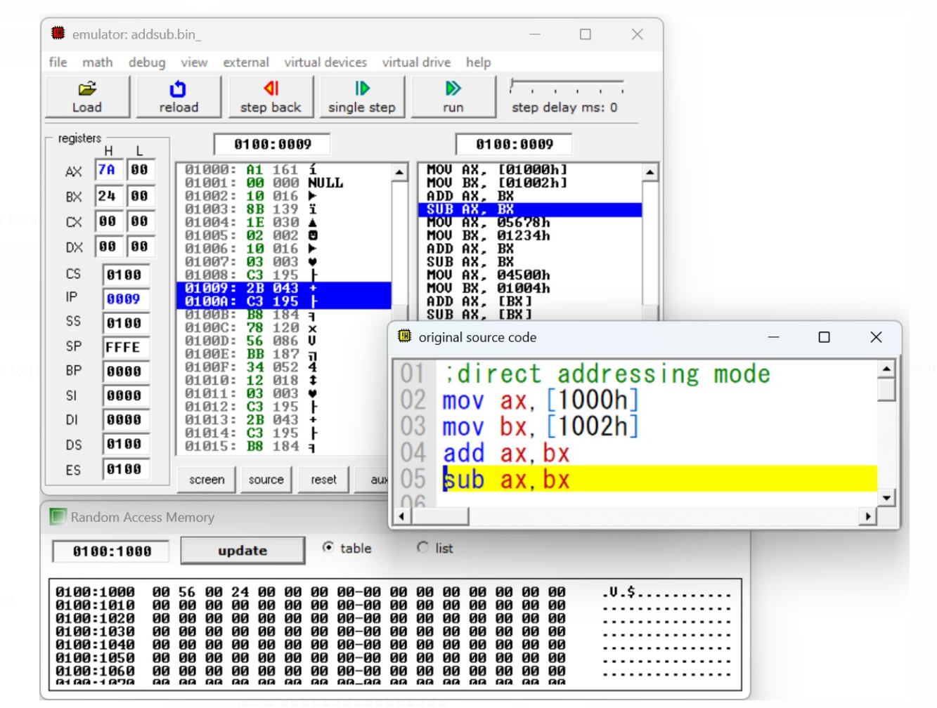

**Direct addressing mode (Subtraction):**

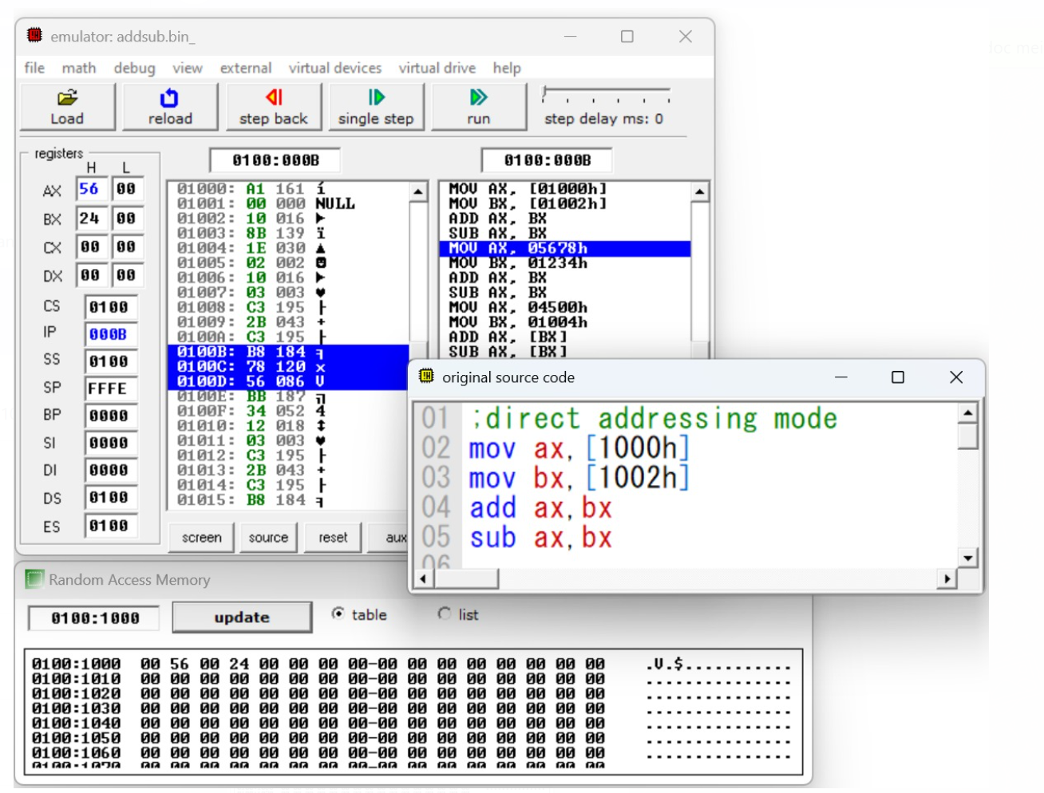

**Immediate addressing mode (Addition):**

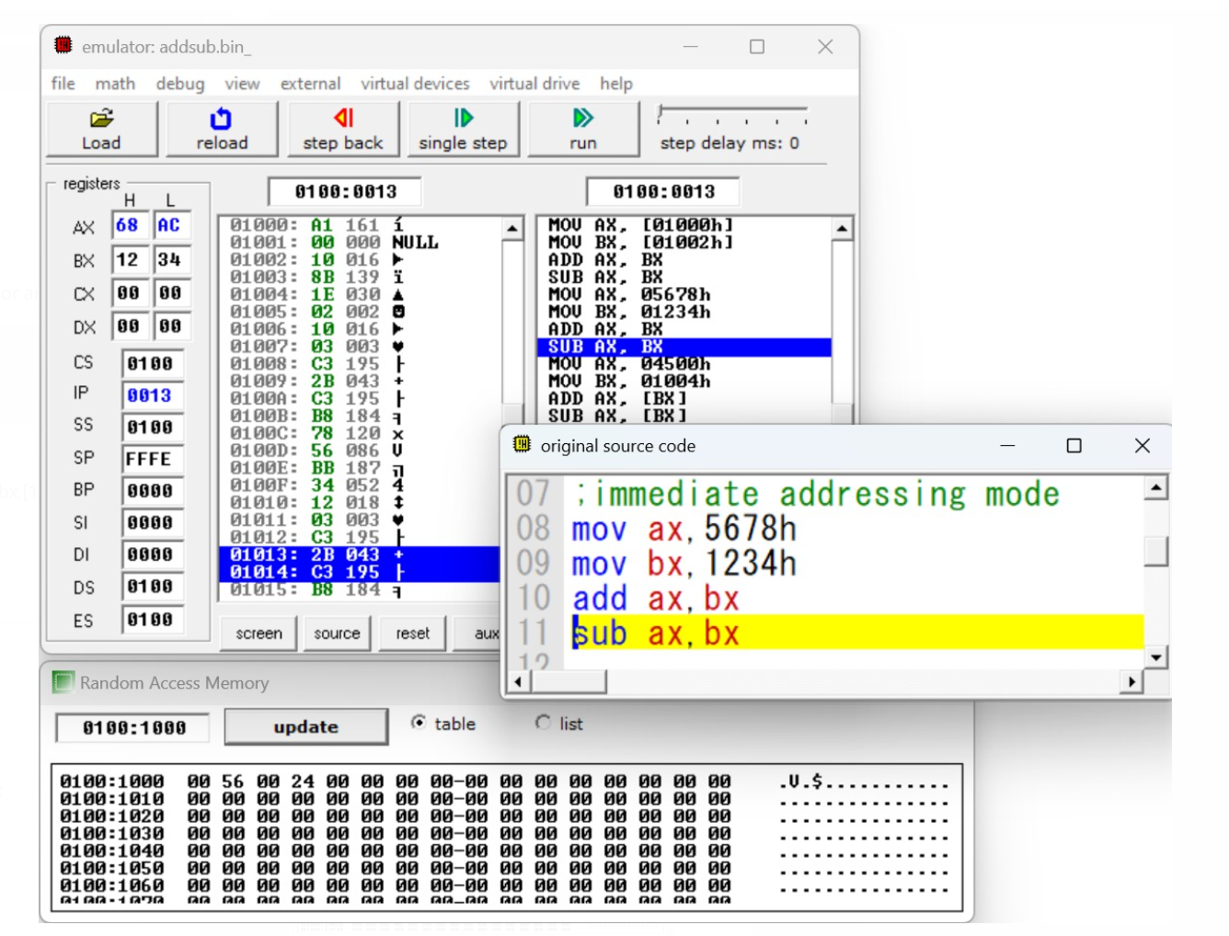

**Immediate Addressing (Subtraction):**

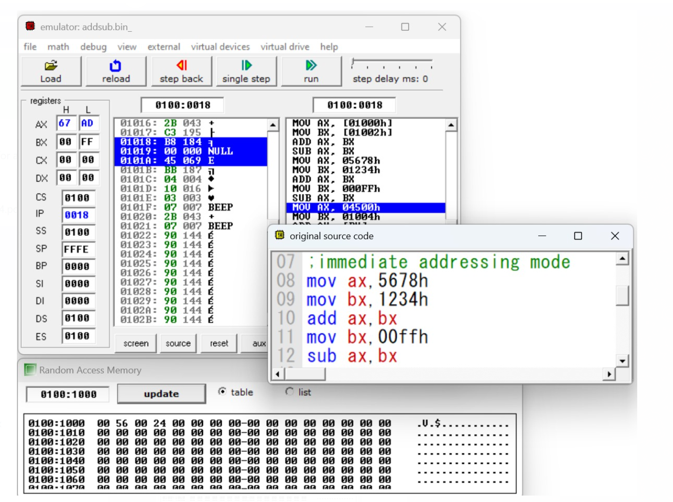

**Register indirect addressing mode (Addition):**

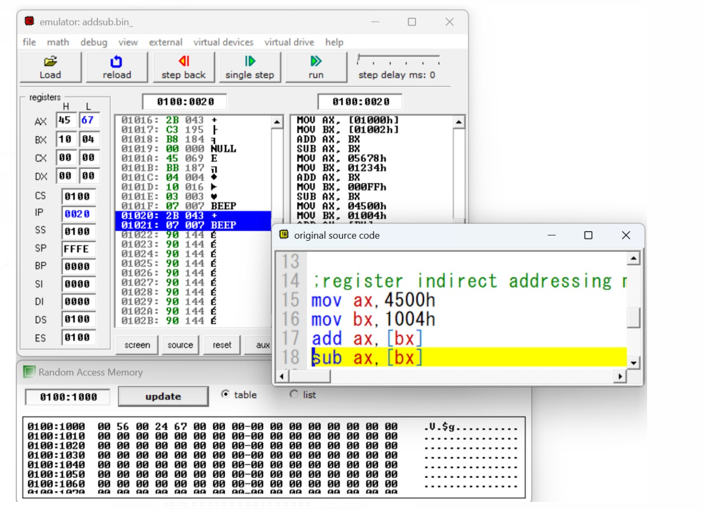

**Register indirect addressing mode (Subtraction):**

